**NOAA Ship THOMAS JEFFERSON Procedure Document**

Procedure:

**Sutron bubbler start up**

Creation Date:

8/27/2020

Revision Date:

Software used:

Procedure Number:

**TBD**

Approved:

**TBD**

# Overview and Scope

Sutron bubbler start up

# Procedure Inputs and Outputs

## Inputs:

## Outputs:

1. Is the unit behind the server rack plugged in? If you hit any button and the screen does not illuminate on the repeater, it is likely unplugged. Simply plug in to a power strip or the Rhino power box as seen below.

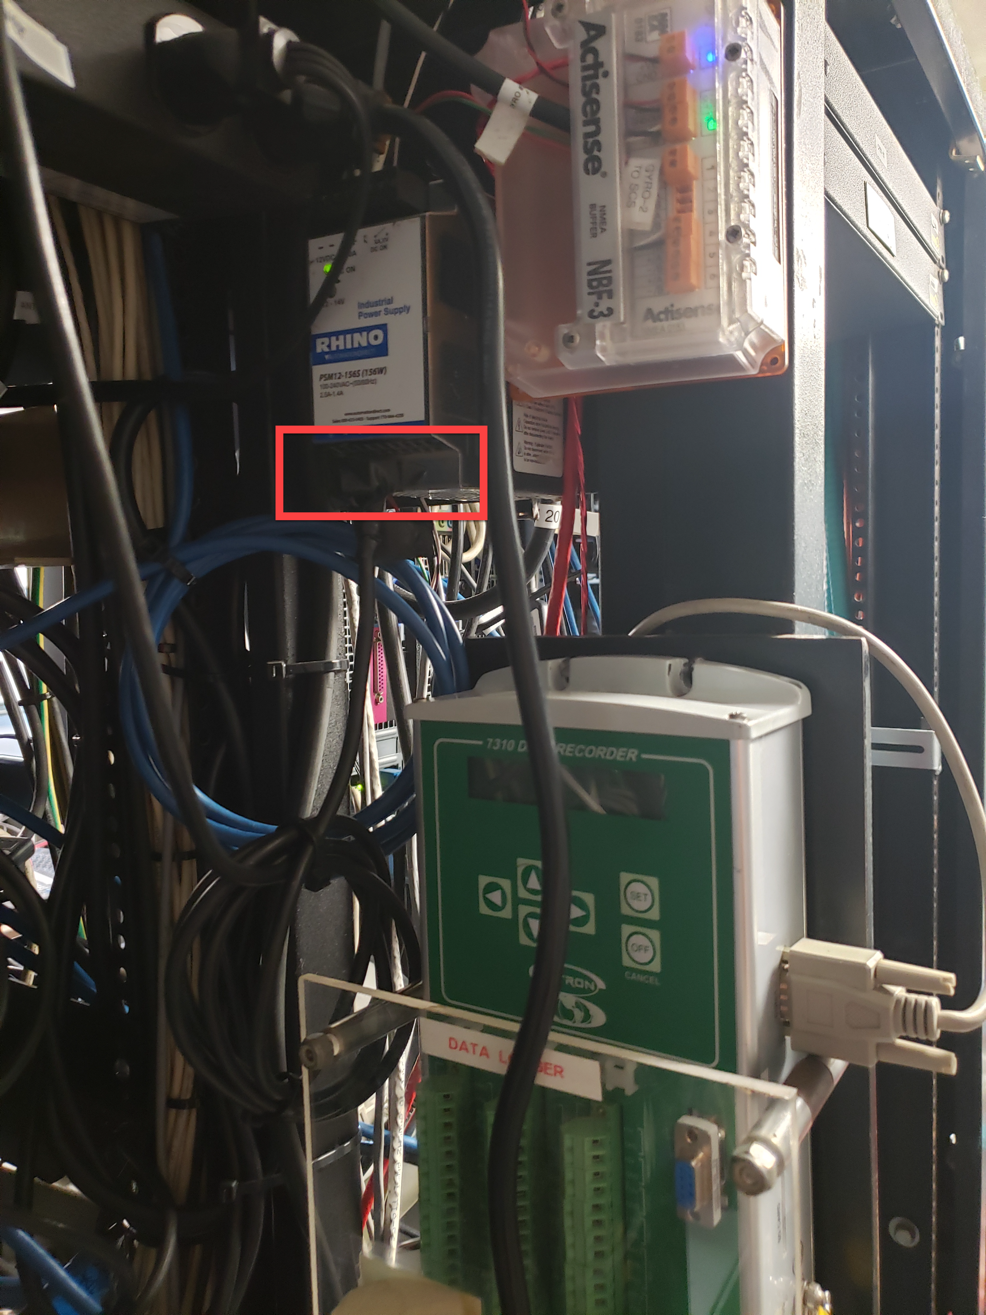

1. In the sonar void (above the thru hull Valeport), there is a well-hidden valve that needs to be in line with the pipe. 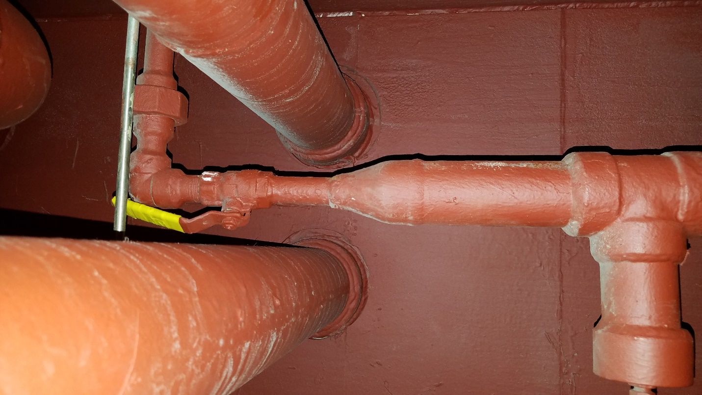
2. Also in the sonar void, there is a large ball valve on the inboard bulkhead. Image below taken from the stairs into the void from the gym. Turn the valve all the way to the left and ¼ turn back to the right:

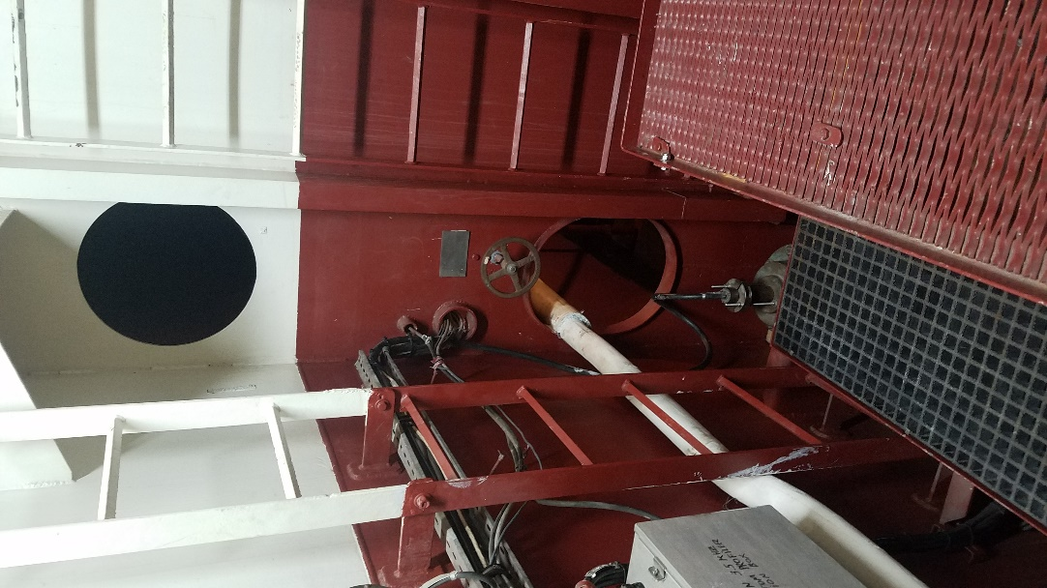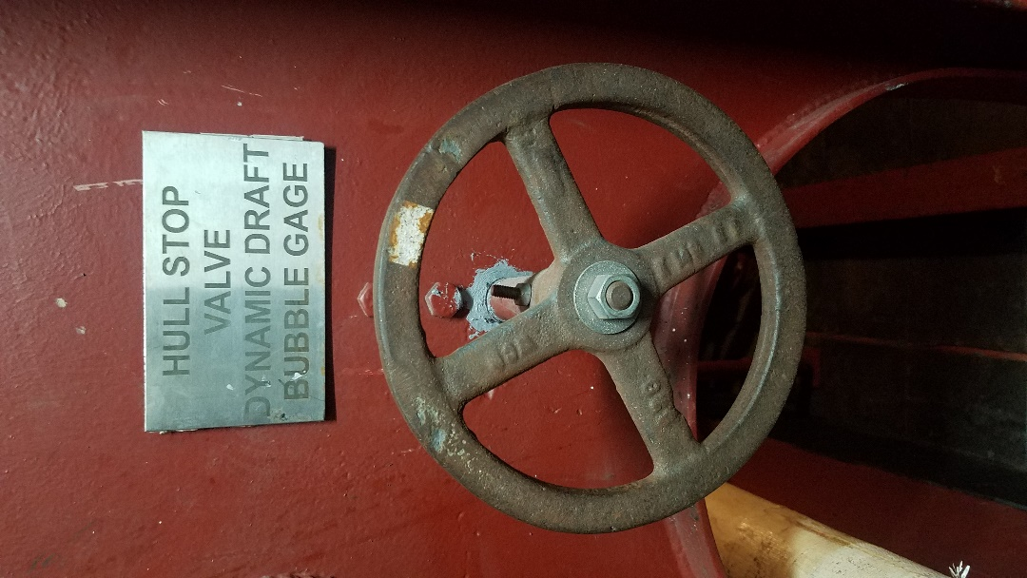

1. Finally, is the purge valve open on the bow fo’c’sle? Main valve should be in line (bottom) and air purge (top) should be closed as pictured. The “purge” bucket needs to be dumped every 2-5 days while underway. ***If the display in the plot room ever indicates a blockage, reverse the valves and connect the air hose to push blockage out. . ****

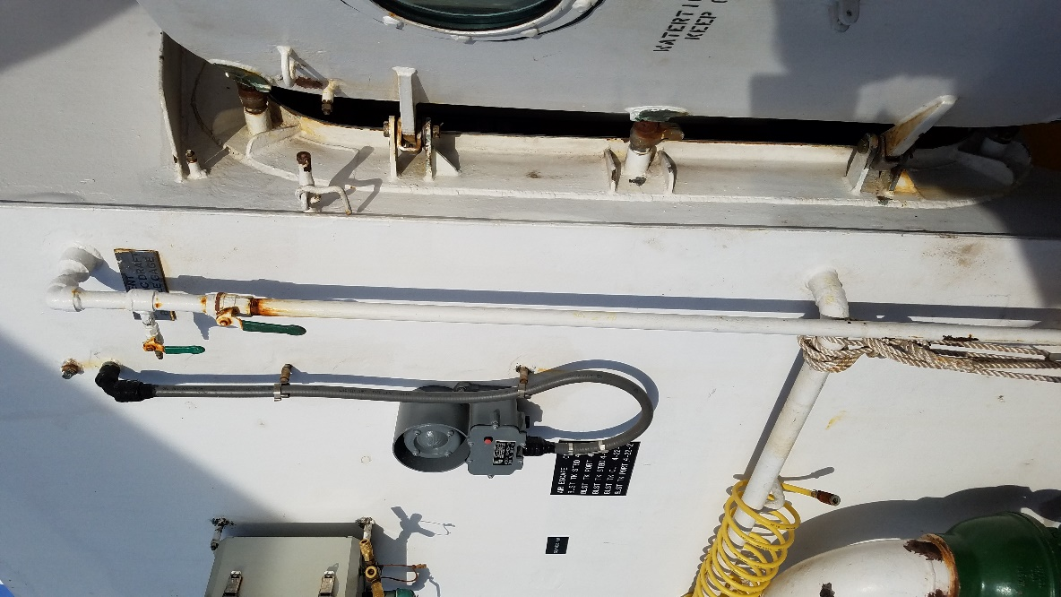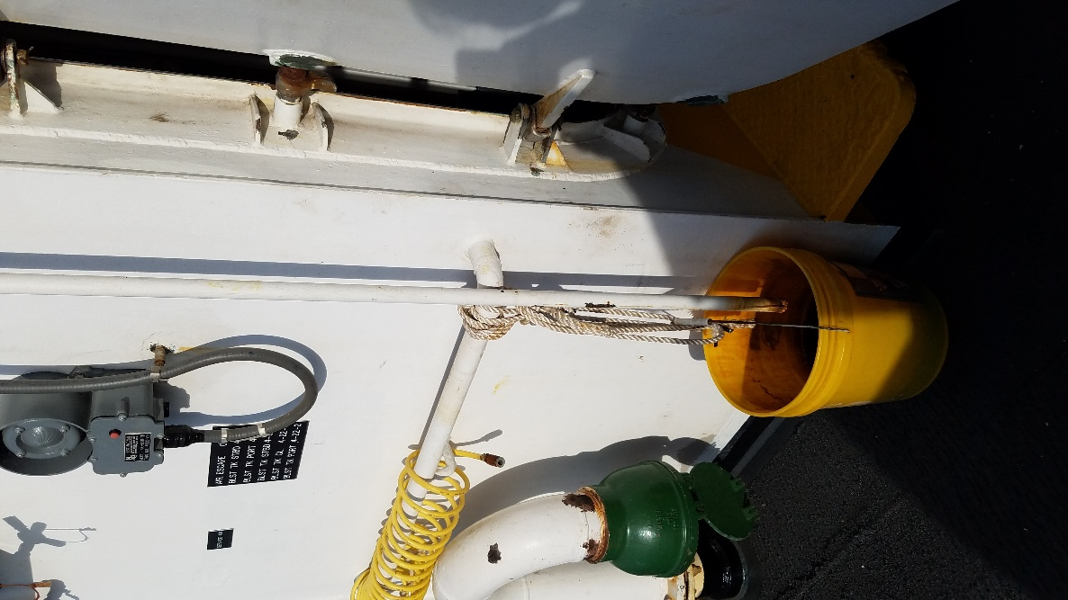

If the Sutron bubbler is giving a WL reading somewhere between 0.5 and 2.0+ SOMETHING IS NOT SETUP CORRECTLY or there is a blockage. We have had an issue where we had to blow out the blockage trying 5 or 6 times till seeing an accurate reading. Do not set the PSI higher than 100PSI.

# References

N/A